Week Commencing: Monday 29th July
 | MON | TUE | WED | THU | FRI | SAT | SUN
Morning | Morning Papers & TV | One to One  Time | Hairdresser On Holiday | One to One  Time | Craft Session  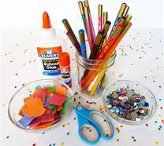
Afternoon | Painting  Pat Dog  Wedgie | Chair Aerobics with Caroline | Bingo | Play Your Cards Right | Sweet Trolley  Movie

